European stakeholders to discuss future of railways at the Shift2Rail Dialogue at the Digital Transport Days

September 30, 2019

Category: [Latest News](https://shift2rail.org/news/), [newsletter9](https://shift2rail.org/newsletter9/)

**More than 200 participants from across Europe will take part in the Shift2Rail Dialogue at the Digital Transport Days, which will take place on 7 October 2019 in Helsinki.**

[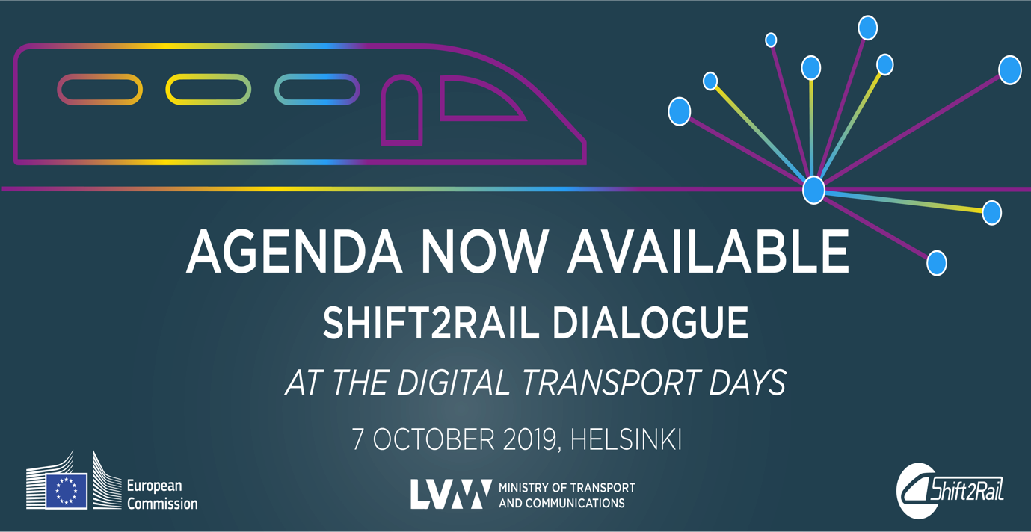](https://www.digitaltransport.eu/2019/pages/shift-to-rail)

The event will consist of two panel discussions and a presentation on the expected results of Shift2Rail innovations. The high level speakers, including Mr. Mikko Koskinen, Secretary of State to the Finnish Minister of Transport and Communications and Mr. Henrik Hololei, Director-General for Mobility and Transport will discuss the future of digitalisation and new technologies in the railway industry and exchange about Shift2Rail’s role in moving the European railways forward.

After the workshop, visitors will be welcome to visit the Shift2Rail stand at the Digital Transport Days Exhibition area where they will have the opportunity to find out more about Shifft2Rail’s latest R&I activities, focusing on results to date.